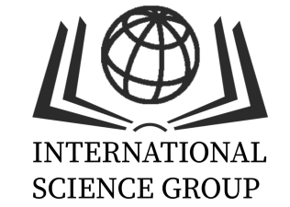
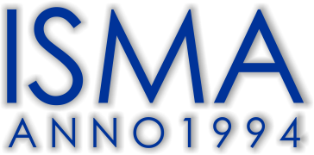

Scientific and pedagogical internship "Theory and practice of scientific and pedagogical approaches in education"
AUTUMN SEMESTER 2021/2022

Organizers: ISMA University of Applied Sciences (ISMA) (Riga, Latvia) with the support of International Science Group (https://isg-konf.com/internship/) (accompanied by a signed cooperation agreement).

Schedule of the internship:
Module, topics* | Period | Credits/ hours
Module 1, topics:  - Issues of academic mobility, internationalization of scientific research (including regulatory support).  - Total quality management implementation in educational institution  - Modern trends in vocational guidance and career building | 01.11.2021.-  01.12.2021. | 6/180
Module 2, topics:  - Scientific writing and academic integrity  - Ranking system of higher education institutions  - Modern trends in vocational guidance and career building | 22.11.2021.-  22.12.2021. | 6/180
Module 3, topics:  - Business communication in modern entrepreneurship environment  - Issues of academic mobility, internationalization of scientific  - Interdisciplinary approach to the construction of educational programs | 13.12.2021.-13.01.2022. | 6/180
Module 4, topics:  - Total quality management implementation in educational institution  - Preventing professional burnout among university teaching staff  - Coaching methods in the educational process within higher education | 17.01.2022.-  17.02.2022. | 6/180
*Modules topics and content might be updated due to circumstances, participants will be informed in advance.

